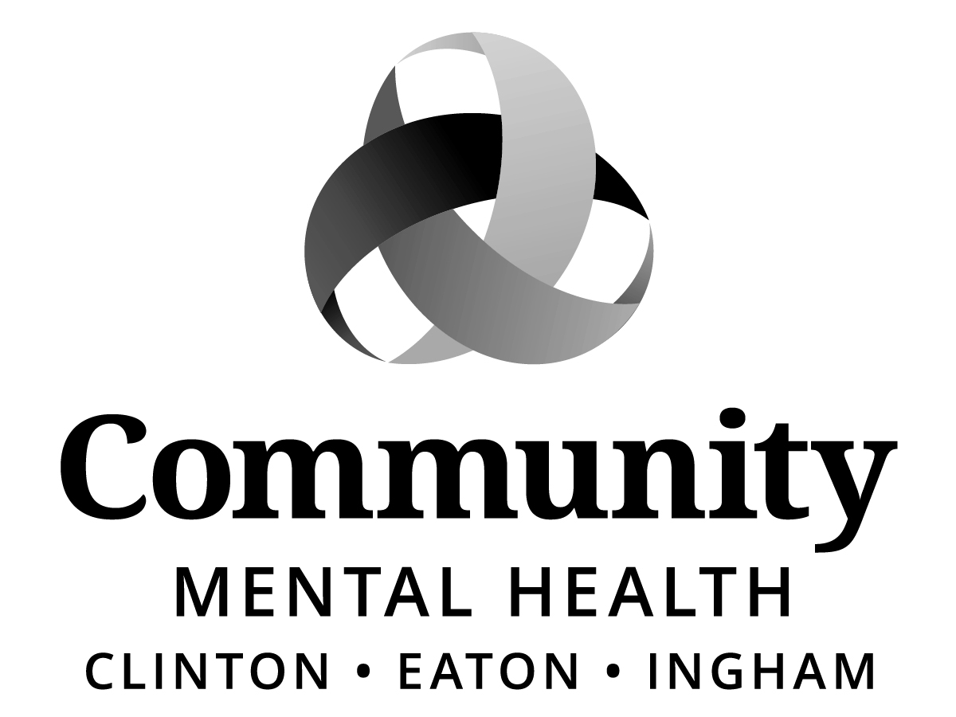

BOARD OF DIRECTORS
MEETING MINUTES
Thursday, May 18, 2017, 6:00 p.m.
812 E. Jolly Road, G11-C
Lansing, MI 48910

Staff Present:
Shana Badgley, Sharon Blizzard, Karla Block, Stacia Chick, Aleshia Echols, Ericanne Spence, Joanne Holland, Sara Lurie, Jennifer Stanley, Gwenda Summers

Public Present:
Denise King, consumer guardian
Elizabeth Pratt, NAMI

Excused (advance notification provided)
Dianne Holman, Stephen Manchester, Chris Swope, Maxine Thome

Call to Order:
The meeting was called to order by Chairperson, Kay Pray at 6:03 p.m.

Roll Call:
Joe Brehler, Raul Gonzales, Carol Koenig, Paul Palmer, Kay Pray, Kay Randolph-Back, Jim Rundborg, Kam Washburn

Previous Meeting Minutes:
ACTION:
MOVED by Raul Gonzales and SUPPORTED by Paul Palmer to approve meeting minutes of April 20, 2017 as written.

MOTION CARRIED unanimously.

Adoption of Agenda
ACTION:
MOVED by Carol Koenig and SUPPORTED by Raul Gonzales to adopt the meeting for May 18, 2017.

MOTION CARRIED unanimously.

Public Comment on Agenda Items:
None.

Mid-State Health Network Update (MSHN)
Joe Brehler reported that Board of Directors for Mid-State Health Network met on Tuesday, May 2 and that much of the discussion evolved around the following items:
- 2 CMH’s that are having cash flow problems and actions that will be taken to remedy these matters, and
- $5 million dollars Projected Trending Lapse with the autism fund offsetting much of it, $3.1 million of Medicaid funds; and $1.9 million of Healthy MI funds being returned to MSHN. Depending on what happens on a federal and state level will determine future Medicaid fund availability.

Chief Executive Officer Report
Sara Lurie, CEO reported that at the end of March, 2017; Paul Palmer attended the 2017 Disability Policy Seminar in Washington, DC and this evening he will be presenting some of the key points shared at the seminar:

- Federal Funding,
- Healthcare,
- Medicaid and Long Term Support and Services,
- Social Security and Social Security Income,
- What does the future look like?

ACTION: A copy of the 2017 Disability Policy Seminar presentation is attached.

Sara Lurie thanked Paul Palmer for his attendance at the 2017 Disability Policy Seminar, and moved quickly into how Mr. Palmer’s presentation was a good segway into what is happening at the national level, and how it is distracting what is happening on a state and federal level right now; and that if enacted would greatly impact funding levels, and operations. Due to the fact that originally legislation was not going to be taken up until September but now there are talks about pushing this through in August. Ms. Lurie stated that it is vitally important that we be aware of these issues, educate staff, consumers and family members, and encourage people to take action as citizens to express their views with legislators. High levels of citizen advocacy have made a difference in the past and must continue to be sustained right now.

Ms. Lurie reported that the focus is on promoting the complete removal of section 234 language and of language that supports pilot projects for Michigan Health Plans.

There is some feeling that pilots with Michigan Health Plans are inevitable at this point, so additional message is if they are included, they must:
- Adhere to the same requirements and reporting that PIHP/CMH’s do
- Participants must be able to opt in or out of pilots
- Clear definition of purpose and outcomes for these projects
- Evaluation by a third party research institution
- Any waiver or statute changes required to run a pilot can only be in effect for the designated pilot period

Ms. Lurie commended the union for their active role in getting the word out statewide opposing CMH privatization by offering evening phone banking opportunities for the past several weeks in their office. Their impact is on reaching people! Discussion ensued.

Action Alerts were sent to board members, staff, community partners, and County Commissioners for Eaton, Ingham and Clinton Counties received copies of resolutions to present to their boards.

Additionally, very troubling is that the state level problems are a distraction from what we are also dealing with at a federal level. We are hearing that the Senate is looking at working on their legislation in June with hope of voting before going on recess in August. Just as in the house, there are no plans to hold hearings. While our Michigan Senators are solidly opposed to the proposed changes in Medicaid funding, it was recommended that we continue to educate our Michigan House Republicans.

ACTION: Direct contact with legislators via phone, face-to-face, email would be greatly appreciated to assure that legislators understand the destabilizing impact this would create in our counties.

Other highlights include:
- Upcoming NAMI Event on Assisted Outpatient Treatment (Kevin’s Law)
Treating A Lack of Insight in Mental Illness
Monday, June 5, 2017 @ 6:30 p.m.
Ingham County Human Resource Building
- Cedar Lansing

Kay Randolph-Back encouraged board members to attend the upcoming NAMI event although very complicated and challenging to interpret, found it to be a very good resource of information based on some serious analysis.

- 13 Reasons Why – coverage by WILX, Channel 10, 6:00 p.m. News Tonight

http://www.wilx.com/content/news/SPECIAL-REPORT-PREVIEW-Should-teens-watch-this-controversial-show-422814834.html

The show is called 13 reasons why and it has drawn a lot of interest from teens and parents who want to know what the buzz is all about to suicide prevention groups expressing major concern.

Mental Health advocate Gwenda Summers says it glamorizes teen suicide and endangers vulnerable teens.

- Announcement of the Gil DeRath Humanitarian Award to Ms. Kelly Gluszewski, Clinical Coordinator, Family Guidance Services

BUSINESS ITEMS:
Program and Planning
New Expense Contract: Starfish Family Services

ACTION:
MOVED by Raul Gonzales and SUPPORTED by Paul Palmer that the Board of Directors of Community Mental Health Authority of Clinton, Eaton, and Ingham Counties authorize CMHA-CEI to enter into a new contract with Starfish Family Services to provide the services at the rates listed below for the period of April 1, 2017 through September 30, 2017.

Psychiatric Evaluation | 342.00 | Encounter
Initial or Other Assess - LLP/non-Phys | 245.00 | Encounter
Treatment Planning/Person Centered Plan | 234.00 | Encounter
Ind therapy, 17-37 minutes face-to-face | 108.00 | Encounter
Ind therapy, 38-52 minutes face-to-face | 180.00 | Encounter
Ind therapy, 53-90 minutes face-to-face | 240.00 | Encounter
Family therapy client not present | 150.00 | Encounter
Family therapy client present | 174.00 | Encounter
Eval & Mgmt (Medication Review) | 90.00 | Encounter
Eval & Mgmt (Medication Review) | 114.00 | Encounter
Eval & Mgmt (Medication Review) | 186.00 | Encounter
Eval & Mgmt (Medication Review) | 216.00 | Encounter
Eval & Mgmt (Medication Review) | 234.00 | Encounter
Case Management | 67.80 | 15 min unit
Homebased | 84.00 | 15 min unit

MOTION CARRIED unanimously.

New Expense Contract: Walnut Ridge County Estate LLC Adult Foster Care Stockbridge
ACTION:
MOVED by Raul Gonzales and SUPPORTED by Jim Rundborg that the Board of Directors of Community Mental Health Authority of Clinton, Eaton, and Ingham Counties authorize CMHA-CEI to enter into a contract with Jeffrey Shepherd at Walnut Ridge Country Estate, LLC, Adult Foster Care in Stockbridge to provide services at the per diem rates of $20.11 (Level I), $40.21(Level II), and $60.32 (Level III), paid on a monthly actual usage basis for the period of June 1, 2017 through September 30, 2017.

MOTION CARRIED unanimously.

New Expense Contract: First Light Home Care
ACTION:
MOVED by Raul Gonzales and SUPPORTED by Carol Koenig that the Board of Directors of Community Mental Health Authority of Clinton, Eaton, and Ingham Counties authorize CMHA-CEI to enter into a new contract and to purchase Community Living Supports and Respite Services from First Light Home Care for the period of May 1, 2017 through September 30, 2017 and pay according to the rate schedule below for those services/goods.

Rate Schedule
Service | Hourly Standard Rate | Hourly Holiday Rate
Children’s Waiver, CLS, and Respite* | $16.92/hr. | $25.44/hr.
CLS and Respite-Hab. Waiver /B3* | $14.88 or $16.92/hr.* | $22.24 or $25.44/hr*
CLS and Respite – Sleeper Rate | $10.36/hr.
*Rate varies depending on the support needs of the individual served. A per diem rate may be utilized that is calculated by the board approved hourly rate multiplied by the number of authorized hours per the individual’s level of care and need.
MOTION CARRIED unanimously.

Finance Committee
Contract Renewal: Respite Services Provider/Camps
ACTION:
MOVED by Raul Gonzales and SUPPORTED by Paul Palmer that the Board of Directors of Community Mental Health Authority of Clinton, Eaton, and Ingham Counties Board of Directors authorize CMHA-CEI to enter into contract renewals with the camps listed below to purchase respite care services for the period of June 1, 2017 thru September 30, 2017 and pay out of individuals authorized respite allotment for those services / goods.

Name of Camp | Address of Camp | Cost
Albright United Methodist Church Camp-Special People Camp | 3156 190th Ave., Reed City, MI 49677-9731  Office 888-217-1905  Box 84, Oshtemo, MI 49077  Camp Lynn:231-832-9094 | Developmentally Disabled rates: Adults - $385
Bay Cliff Health Camp | P.O. Box 310, 4175 Bay Cliff Dr., Big Bay, MI 49808 906-345-9314 | Less than $700/week; $2,900 for 7 weeks
Beekman Therapeutic Horseback Riding Camp | 2901 Wabash Rd., Lansing, MI 48910  517-755-2175 | $35 private therapy 30 minutes; YMCA Camp $10/child for 5 days
Camp Sunshine - Camp Blodgett | 430 E. 8th St., Holland, MI 49423 616-994-9897 | Income based/Size of household; Avg-$100 per child for 4 wks
Camp Concordia | 13400 Pinewood Street, Gowen, MI 49326  616-754-3785 office@campcondordia.org | $288 for 4 days
Camp Fish Tales | 2177 E. Erickson Rd., Pinconning, MI 38650  989-879-5199 | Level 1-$625 Level 2-$850  Level 3- $1,150
Camp Greenwood | 13564 McClain Rd., Gowana, MI 49326  231-224-3059 | $175-$350 depending on session
Camp Henry | 5575 Gordon Ave., Newaygo, MI 49337  616-459-2267 | $310 and up, dependent on duration and age of camper
Camp Living Waters | 536 E. 6 Mile Road, Luther, MI 49656  231-797-5107 www.camplivingwaters.org | $419 for 5 days-$50 non-refundable fee
Camp Midicha | 10407 N. Fenton Rd., Fenton, MI 48430  810-629-9622 (Summer) | $700-1200/week average
Camp Pa-Wa-Pi, Parkwood YMCA | 3232 E. Grand River, Williamston, MI 48895  517-827-9680 Lansing Office | Fee per type of session  $130 - 160
Camp Sunshine – Holt Lutheran Church | 2418 Aurelius Rd., Holt, MI 48842  517-694-3182 | $300 Scholarships avail
Conductive Learning Center at Aquinas College | 2428 Burton St., SE, Grand Rapids, MI 49546 616-575-0575 | $2,800 for the 3 week summer program-$25 fee
Cran-Hill Ranch, Friendship Camp | 14444 17 Mile Rd., Rodney, MI 49342  231-796-7669 | Week 1-$485 Week-9-$485  Week 3-$485
Delta Mills Nazarene Camp | 6816 Delta River Dr., Lansing, MI 48906  517-321-8643 | $125 activity fee for summer in addition to $116/per week
Fowler Center | 2315 Harmon Lake Rd., Mayville, MI 48744  989-673-2050 | Fees per type of session  $195-1,272
HisAbility, Camp Barakel | P.O. Box 159, Fairview, MI 48621  989-848-2279 | $185—Depends on age group
Holt Lutheran Summer Camp, Hawks Program | 2418 Aurelius Rd., Holt, MI 48842  517-694-3182 | $140 per week,  $30 registration fee
Impressions-5 Museum | 200 Museum Dr., Lansing, MI 48833  (517) 485-8116 ext. 132  Attn: Katie Rosenberg | Non-members $350/week; members $275/week; April 3-7 2017
Information Technology Empowerment Center – Summer Courses | 200 North Foster, Lansing, MI 48912  admin@iteclansing.org 517- 708-4390 | $100-$140  Income scholarships available $25-$50
Lansing Parks & Recreation | 1011 N. Fairview Ave., Lansing, MI 48912  517-483-4277 | Up to $500 depending on the type of program
Lansing Parks/Recreation, Southside Community Center | 5825 Wise Road, Lansing, MI 48911  517-483-6686 | $30 - $95 per week Depending on type of program & county /city residence
Mystic Lake | 9465 Ludington Dr., Box 100, Lake, MI 48632 517-827-9650 | 1 week-$520  2 weeks-$950
Oak Park YMCA | 900 Long Blvd., Lansing, MI 48911  517-827-9700 | Fees per type of session  $118-158; $35 deposit
Okemos Special Needs Camp | 1826 Osage Dr., Okemos, MI 48864  517-706-5020 | 4 weeks - $801; 5 weeks - $946; 6 weeks - $1,127; 7 weeks - $1,304
Pine Ridge Bible Camp | 8415 17 Mile Rd., Cedar Springs, MI 49319  616-696-8675 | $315-Freddie Friends; $75 deposit-June 13-16th; $380-July 3-7th
Ric Star-MSU Music Camp | 4390 S. Hagadorn, East Lansing, MI 48823  517-884-4828 | June 15-17th (Adults; 9am-3pm)  June 19-21st (Youth/Adolescents; 9:30am-2:30pm)  $200 Per camper
Spring Hills Camp | Box 100, Everat, MI 49631  231-734-2616 | $277-$707-depending on session
St. Francis on the Lake | 10120 Murray Rd., Jerome, MI 49249  517-688-9212 – e-mail in registrations | $525/week; $250 deposit: 1-1 is an extra $150
Young Life Camp-Timberwolf Lake | 1518 River Terrace Dr., East Lansing, MI 48823 Registration 517-324-3294  4898 N. Morey Rd., Lake City, MI 49651  Camp 231-839-7552 | $650  $125-150 for November
PEAC | 32 N. Washington, Suite 1, Ypsilanti MI 48197  734-484-2758  info@bikeprogram.org | $35 per student
Zookambi Summer Camp – Potter Park Zoo |  | Grades 1-7, 1 week sessions  $95 ½ day, $190 full  Members $80/$160

MOTION CARRIED unanimously.

Revenue Contract Amendment: Ingham County, Office of Community Corrections
ACTION:
MOVED by Joe Brehler and SUPPORTED by Raul Gonzales that the Board of Directors of Community Mental Health Authority of Clinton, Eaton, and Ingham Counties Board of Directors authorize CMHA-CEI to approve a contract amendment with the Ingham County Office of Community Corrections to provide women specific treatment in addiction services for the period of April 1, 2017 through September 30, 2017 and receive for those services $10,349.00.

MOTION CARRIED unanimously.

Revenue Contract Amended Funding: City of Lansing
ACTION:
MOVED by Joe Brehler and SUPPORTED by Kay Randolph-Back that the Board of Directors of Community Mental Health Authority of Clinton, Eaton, and Ingham Counties authorize CMHA-CEI to enter into a contract with City of Lansing for the period of 10/1/2016 to 7/1/2017 and receive $35,000 to help cover General Fund costs of Bridges Crisis Unit.

MOTION CARRIED unanimously.

Access Ad Hoc Committee
Sara Lurie reported that MaryAnn Ford, Consultant for Capital Area Health Alliance will be our guest speaker addressing workforce issues – psychiatrist shortages at the next regularly scheduled meeting on May 22, 2017 at 5:00 p.m., in G11-C conference room.

Building & Sites Ad Hoc Committee
Stacia Chick reported that the bond was approved by Building Authority and Building with a 3 percent rate. John Peiffer, Facilities and Management Manager is working with Clark Construction regarding a construction start date. In addition, Sara Lurie announced that a ground breaking ceremony with the CMHA-CEI Board of Directors will be scheduled once a date is confirmed.

Old Business
None.

New Business
MACMHB Conference Updates:
During the MACMHB Spring Conference in Dearborn, MI held May 15 – May 17, Raul Gonzales reported attending a session regarding Kevin’s Law. During this session, he had an opportunity to hear the perspective of both a Judge and Mark Reinstein, PhD, President and CEO, Mental Health Association in Michigan and found it to be a very complicated and challenging process. Board member, Raul Gonzales also agrees with Board member, Kay Randolph-Back that board members would find this event very informative.

Raul Gonzales commented that the Spring Conference was pretty much the same as in past years with great presenters with cutting edge information and agreed with Kay Randolph-Back AOT is well worth time. Community engagement and education.

Kay Randolph-Back distributed wristband videos, a method used by the Flynn Foundation to get the message out about mental health care and make the video accessible in a simple way. Ms. Randolph-Back shared that this is an idea worth keeping in our mind. To share the various types of services available to consumers.

In addition, Ms. Randolph-Back reported attending the following sessions:
- Health Information Technology workshop, and that it takes operational development, infrastructure and skill to successfully achieve physical and mental health,

- 298/234 Demonstration

- Chairperson Roundtable on behalf of Kay Pray. Topic of discussion: Segregate region wide stakeholder facility for individuals with mental illness.

Carol Koenig reported attending CIT. They talked about what is required to have continuance with this type of program. She also attended a session regarding Jail Diversion and unsuccessful pilot programs, which she found very informational.

Public Comment
Elizabeth Pratt, NAMI made the following announcements:
- Upcoming NAMI Event on Assisted Outpatient Treatment (Kevin’s Law)
Treating A Lack of Insight in Mental Illness
Monday, June 5, 2017 @ 6:30 p.m.

- Extended an invitation to NAMI picnic:

Picnic, Potluck, and Annual Meeting
Wednesday, June 21, 2017
Sharp Park in Delta Township
1401 Elmwood Rd., Lansing
5:30 to 7:30 PM.
And encouraged anyone not on the NAMI mailing list to contact her to be added.

Denise King, consumer guardian announced that staff are working on the move for her brother. However, during the process she discovered some things that she felt she should have been made aware of by CEI, that she was not; which she found very disappointing. However, Ms. King reported that she is believing that the best is yet to come, and asked that the board stay tuned.

Adjournment
The meeting was adjourned at 7:12 p.m. The next meeting is scheduled for Thursday, June 22 , 2017 at the Barry Eaton Health Department, 1033 Health Care Drive, Charlotte, MI; Conference Room, beginning at 6:00 p.m.

Minutes submitted by:

Aleshia Y. Echols
Executive Administrative Assistant

