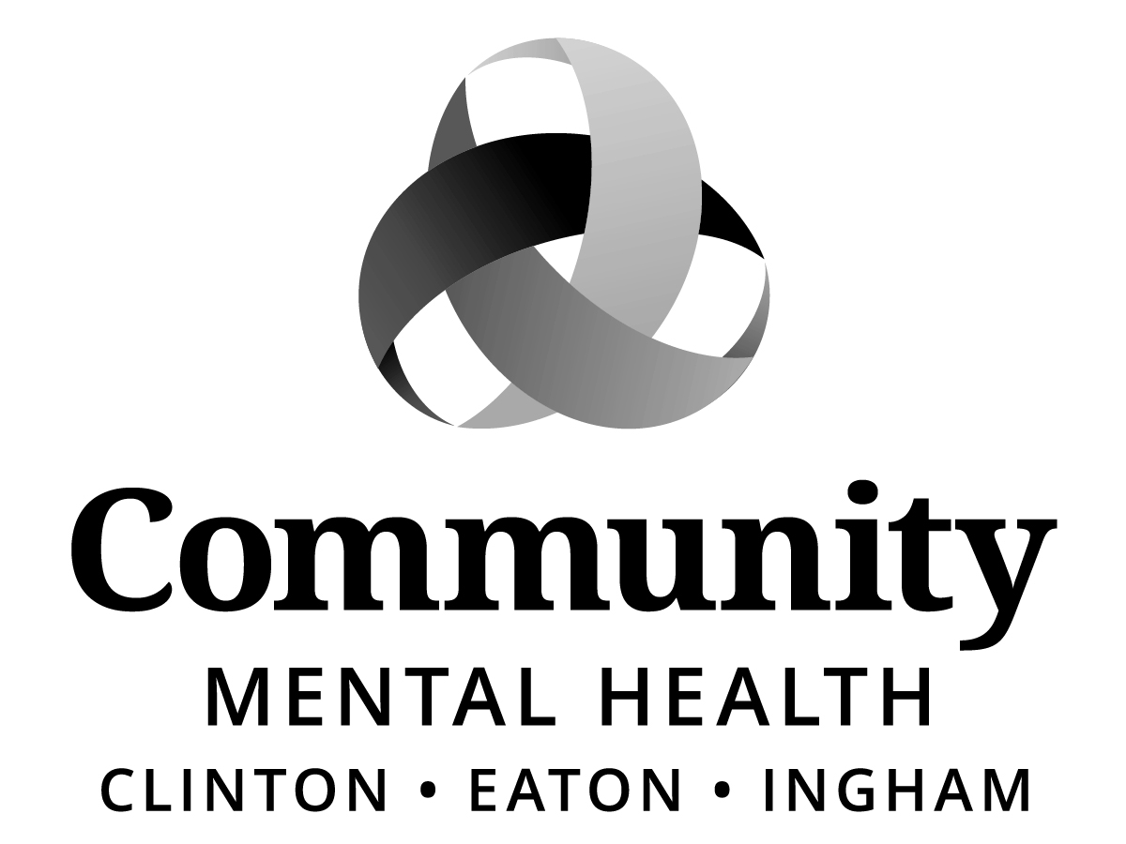

BOARD OF DIRECTORS
MEETING MINUTES
Thursday, August 17, 2017, 6:00 p.m.
1401 W. Herbison Road
DeWitt, MI 48820

Staff Present:
Shana Badgley, Sharon Blizzard, Karla Block, Stacia Chick, Aleshia Echols, Joanne Holland, Sara Lurie, Jennifer Stanley

Public Present:
Jeff Fleming and Naudia Fisher, Local 459

Call to Order:
The meeting was called to order by Chairperson, Kay Pray at 6:02 p.m.

Roll Call:
Joe Brehler, Raul Gonzales, Dianne Holman, Paul Palmer, Kay Pray, Kay Randolph-Back, Jim Rundborg, Maxine Thome, Kam Washburn

Excused (advance notification provided)
Carol Koenig
Stephen Manchester
Chris Swope

Previous Meeting Minutes:
ACTION:
MOVED by Raul Gonzales and SUPPORTED by Kay Randolph-Back to approve the meeting Minutes of July 20, 2017; removing the word “authorize” under OPEIU Local 459 and 512 Negotiations (Closed Session) in both paragraphs, on the bottom of page 10.

MOTION CARRIED unanimously.

Adoption of Agenda
ACTION:
MOVED by Dianne Holman and SUPPORTED by Raul Gonzales to adopt the meeting Agenda for August 17, 2017.

MOTION CARRIED unanimously.

Public Comment on Agenda Items:
None.

Mid-State Health Network Update (MSHN)
Joe Brehler reported that the next MSHN board meeting is scheduled for September 2017. No new information to share at this time. However, MSHN continues to look at ways to coordinate and create efficiencies between CMHs.

Chief Executive Officer Report
Sara Lurie, CEO commended Joyce Tunnard, Quality, Customer Services, and Recipient Rights (QCSRR) Director; with a special recognition of staff members: Emily Wollner, Elise Magen and Stefanie Zin for their efforts over the past year and for taking care of all of the logistics in preparation for the (August 14 – 16^{th.}) onsite CARF Accreditation Review. In addition, Sara thanked all who prepared for and/or participated in this review and shared that during the exit session, reviewers provided some initial feedback on recommendations they will be including in the report, along with a lengthy list of strengths they observed when visiting programs, talking with staff, reviewing charts, and interviewing stakeholders, consumers, and one of the board members. Once the detailed written report is received, recommendations will be studied and addressed.

Here are some of the strengths reviewers shared during the exit session:
Input from persons served is analyzed, taken to leadership and utilized; leadership is committed to care; very active in the community/county groups and coalitions; training provided is comprehensive; diligent about rights review; cutting edge on integrated health (Birch Clinic, St. John’s Pharmacy); Families Forward team is impressive, staff glow about their work, parents are supported and learn skills; dignity and respect is upheld; high quality clinical service, very dedicated and professional staff, extensive use of evidence based practices; psychiatry staff and willingness to bring in tele- psychiatry to meet unmet needs was applauded; they were also very impressed with the teamwork in the ACT program, the strong relationship with families in our CSDD Life Consultation program, and the skill building and support at Charterhouse and at our Jolly Java store.

In approximately six weeks’ CEI will receive the CARF Accreditation Report with recommendations and the determination as to whether we earned a one-year provisional or three year Accreditation.

Additionally Ms. Lurie, provided updates on the following items:

Section 298
Referenced pages 32 – 49, August 17, 2017 CMHA-CEI Board of Director packet highlighting:
- Michigan begins to design 4 pilot projects to test mental health integration (Crain’s Detroit Business, August 4, 2017 Jay Greene article,)
- MACMHB post 298 strategic plan passed by MACMHB Executive Board on August 4, 2017,
- Attachment A – Full Transcript of Section 298 of the MDHHS FY18 Budget Bill,
- Attachment B – Principles and aims around which this strategy will be designed,
- Facilitator selected, however, has not yet been officially announced.

CARES Task Force
The Michigan House of Representatives is holding hearings on mental health.
House Speaker Tom Leonard created the bipartisan House C.A.R.E.S. (Community, Access, Resources, Education and Safety) task force to receive input from individuals and professionals on how to improve mental health services in Michigan.

The information gathered will help develop legislation to reform mental health services across Michigan to address veterans’ care, substance abuse treatment, mental health courts, and training for law enforcement.

The Lansing hearing is Thursday, Sept 7 from 1 to 3 in House Appropriations Room, State Capitol.

Seeking Safety Groups at CMHA-CEI
Article highlighted in this months’ CEO Report, provided by Kevin Wing, AMHS Wellness-Forest Coordinator. Regretfully Ms. Lurie announced that Mr. Wing passed away on August 14, 2017 unexpectedly.

Kevin left a big footprint at CEI in a very short period and staff, consumers and community partners will miss him.

BUSINESS ITEMS:
Program and Planning
New Expense Contract: Contract with Westbrook Recovery Services for the Provision of Medical Oversight at the Recovery Center
ACTION:
MOVED by Raul Gonzales and SUPPORTED by Paul Palmer that the Board of Directors of Community Mental Health Authority of Clinton, Eaton, and Ingham Counties to table this item until the September Program & Planning Committee Meeting.

MOTION CARRIED unanimously.

New Expense Contract/Memorandum of Understanding (MOU): University of Michigan
ACTION:
MOVED by Raul Gonzales and SUPPORTED by Jim Rundborg that the Board of Directors of Community Mental Health Authority of Clinton, Eaton, and Ingham Counties authorize CMHA-CEI to enter into an MOU with University of Michigan so CMHA-CEI can provide therapy and support services to Military and Veteran families for the timeframe of FY 2018. University of Michigan, for the period of FY 18, agrees to pay $1000 for the training of two (2) clinical staff and $2500 each for two (2) completed group cycles for the services provided by CMHA-CEI.

MOTION CARRIED unanimously.

New Expense Contract: Shared use of CMHA-CEI Assertive Community Treatment (ACT) program by Ionia County Community Mental Health (ICCMH)
ACTION:
MOVED by Raul Gonzales and SUPPORTED by Maxine Thome that the Board of Directors of Community Mental Health Authority of Clinton, Eaton, and Ingham Counties authorize CMHA-CEI to enter into a Memo of Understanding with the Ionia County Community Mental Health to provide Assertive Community Treatment services. The contract period is from July 1, 2017 and would remain in effect until either organization terminates the agreement, in writing. Reimbursement for individuals admitted into CMHA-CEI ACT will be at current rates.

MOTION CARRIED unanimously.

New Expense Contract: Rock Lake Christian Assembly
ACTION:
MOVED by Raul Gonzales and SUPPORTED by Paul Palmer that the Board of Directors of Community Mental Health Authority of Clinton, Eaton, and Ingham Counties Board of Directors authorize CMHA-CEI to enter into a new contract and to purchase respite services from Rock Lake Christian Assembly and pay the rates listed below for the period of June 1, 2017 through December 31, 2017.
Name of Camp & License # | Address of Camp | Codes | Cost
Rock Lake Christian Assembly  CR590200783 | 7389 Vestaburg Road  Vestaburg, MI 48891  (989) 268-5377 | T1005  H0045  T2036  T2037 | Range of $115 - $300 per session. Sessions range from 3-5 days in length.
*Rate varies depending on the session attended.
Discussion ensued regarding other alternatives in this area and the limited respite providers. A request was made to scout out other options in this region, which Karla Block agreed to pursue.

MOTION CARRIED; with one no vote by Maxine Thome.

Finance Committee
New Expense Contract: Dell Computer
ACTION:
MOVED by Joe Brehler and SUPPORTED by Maxine Thome that the Board of Directors of Community Mental Health Authority of Clinton, Eaton, and Ingham Counties Board of Directors authorize CMHA-CEI to purchase desktop computers from Dell Computer and pay $74,250.00.

MOTION CARRIED unanimously.

ACTION:
MOVED by Joe Brehler and SUPPORTED by Raul Gonzales that the Board of Directors of Community Mental Health Authority of Clinton, Eaton, and Ingham Counties Board of Directors:

Expense Contract Renewal: Saginaw County CMH
- authorize CMHA-CEI to enter into a contract with Saginaw County CMH and pay $27,500 for semi regional coordination, coaching and evaluation (via “fimp”) services for the period of October 1, 2017 through September 30, 2018.
Expense Contract Renewal – Central Michigan CMH
- authorize CMHA-CEI to enter into a contract with Central Michigan and pay $42,079 to provide semi-regional coordination, coaching and evaluation (via “fimp”) services for the period October 1, 2017 through September 30, 2018.

Revenue Contract Renewal: Lansing School District- PEACE Grant
(Promoting Peace by Expanding Awareness of Culture and Equity)
- to enter into a contract renewal with the Lansing School District to provide prevention and intervention services for the period of October 1, 2017 through September 30, 2018 and receive $48,852.00 for those services.

Revenue Contract Renewal- Parent Management Training (PMTO) - Michigan Department of Health and Human Services
- authorize CMHA-CEI to enter into a contract with the Michigan Department of Health and Human Services to provide Parent Management Training- Oregon regional oversight and training for the period of October 1, 2017 through September 30, 2018 and receive $145,000 for those services.

Expense Contract Renewal-addendum: Havenwyck Hospital, 1525 University Dr., Auburn Hills, MI 48326
- authorize CMHA-CEI to enter into a contract renewal with Havenwyck to purchase additional 1-1 staffing and hospital services at the rates and dates indicated below.

Havenwyck: 1-year agreement (8/1/2017 – 9/30/2018) - rates all-inclusive
Inpatient – children, adolescents, adults: $750.00 per day for regular admission.
Additional option for acute cases, with supervisor on call approval: This approval would need to allow the FF Director to approve single case agreements with a contracted hospital, for the 0100 code, in excess of the contract rates in emergent situations. This rate would be $1,150.00 for 1:1 staffing the first 48 hours; pending Supervisor/Director approval.
Expense Contract Renewal: Case Management of Michigan, Kalamazoo, MI 49003
- authorize CMHA-CEI enter into contract renewal with Case Management of Michigan to purchase the below listed services from Case Management of Michigan for the period of October 1, 2017 and ending September 30, 2018.

Service | Code | Unit | Authorized Rate
Case Management | T1017 | 15 Minute | $100.00
Assessment,  Treatment Plan | T1017 | 15 Minute | $100.00
Medication Review | 99213 | Encounter | $75.00
Nursing Evaluation | T1001 | Encounter | $100.00
Nursing Services | T1002 | 15 Minute | $75.00
Group Therapy | 90853 | Encounter | $45.00
Medication Injection | 96372 | Encounter | $21.00
Psychiatric Evaluation | 90791 | Encounter | $100.00

Expense Contract Renewal: Justice in Mental Health Organizations (JIMHO)
- authorize CMHA-CEI to enter into contract renewal with JIMHO to purchase Drop-In/Project Stay services from Justice in Mental Health Organization (JIMHO) for the period of October 1, 2017 through September 30, 2018 and pay $259,426.00 for those services.

Expense Contract Renewal- addendum: BCA – Stonecrest Center, 5000 Gratiot Ave., Detroit, MI 48205
- authorize CMHA-CEI to enter into a contract renewal with Stonecrest to purchase additional 1-1 staffing and hospital services at the rates and dates indicated below.

Stonecrest: 1-year agreement (8/1/2017 – 9/30/2018) - rates all-inclusive
Inpatient – children, adolescents, adults: $627.00 per day
Additional option for acute cases, with supervisor on call approval: This approval would need to allow the AMHS Director to approve single case agreements with a contracted hospital, for the 0100 code, in excess of the contract rates in emergent situations.
  - Staffing first 48 hours: $14.00/hr; pending Supervisor/Director approval

Revenue Contract Renewal: The Right Door for Hope, Recovery and Wellness
- authorize CMHA-CEI to enter into a contract renewal with The Right Door of Hope, Recovery and Wellness to provide Crisis Stabilization Services to The Right Door of Hope, Recovery and Wellness for the period of 10/1/2017 to 9/30/2018 and receive a per diem rate of $454.56 not to exceed $7500.00/year for those services/goods.

Revenue Contract Renewal: 55th District Court
- authorize CMHA-CEI to enter into a contract with the 55th District Court to provide the clinical team for the creation of a Mental Health Court in Ingham County for the period of October 1, 2017 through September 30, 2018 and receive $280,987.

Revenue Contract Renewal: 30th Circuit Court
- authorize CMHA-CEI to enter into a contract with the 30th Circuit Court to provide a .5 FTE Mental Health Therapist and .75 FTE Client Services Specialist for the Mental Health Court in Ingham County for the period of October 1, 2017 through September 30, 2018 and receive $91,194.

Revenue Contract Renewal: 65 B District Regional Mental Health Court
- authorize CMHA-CEI to enter into a contract with the 65 B Regional Mental Health Court to provide a .5 mental health therapist for the implementation of a Mental Health Court in Clinton County for the period of October 1, 2017 through September 30, 2018 for the amount of $39,733.

Revenue Contract Renewal: Michigan Department of Health and Human Services – Projects for Assistance in Transition from Homelessness (PATH) Grant
- authorize CMHA-CEI to renew the revenue contract with Michigan Department of Health and Human Services for the Projects for Assistance in Transition from Homelessness Grant to receive $15,000 which in turn is used to purchase supportive housing services for six homeless adults experiencing mental illness in Eaton County from October 1, 2017 through September 30, 2018.

MOTION CARRIED unanimously.
Preliminary Program Proposals to Balance FY 2018 Budget
ACTION:
MOVED by Joe Brehler and SUPPORTED by Jim Rundborg that the Board of Directors of Community Mental Health Authority of Clinton, Eaton, and Ingham Counties Board of Directors accepts the preliminary program proposals to balance Fiscal Year 2018 budget.

MOTION CARRIED unanimously.

Acceptance of Revised Steady State Budget Projections for Fiscal Year 2017/2018
ACTION:
MOVED by Joe Brehler and SUPPORTED by Kam Washburn that the Board of Directors of Community Mental Health Authority of Clinton, Eaton, and Ingham Counties Board of Directors accepts the Revised Preliminary Steady State Budget Projections for Fiscal Year 2017/2018.

MOTION CARRIED unanimously.
Human Resources Committee
Kam Washburn reported that a special HR Committee, Grievance meeting took place on August 2. Management position was upheld.

Building & Sites Ad Hoc Committee
Sara Lurie announced the new sign-in procedure at 812 E. Jolly Road Facility that was instituted on August 7th, signing-in will be mandatory for any visitors/consumers of CMHA-CEI that enter the facility. All employees are required to have your employee badge on your person at all times during the workday.

The sign-in process is intended to enhance the safe environment within the facility by allowing us to know who is in the building as well as monitor anyone with restrictions due to previously reviewed violence, or ill intent. The process will also assist with incident investigations and with emergency management. Discussion ensued.

ACTION:
The Board of Directors requested that an attendance roster sign in sheet be developed for each of the board committees to be provided to the front reception staff for sign in purposes; preventing committee members from having to complete individual forms upon arrival.

Access Ad Hoc Committee
Dianne Holman reported that the last meeting was on July 24. Copies of the minutes are included in the August board packet. Kay Randolph-Back commented that there was a terrific presentation by the CEI Navigators: Jody Nelson, Lisa McCabe, and Tyler Langoni. Dianne Holman commented that she would like to revisit the discussion and look at thing a little differently based on the presentation at the next meeting. The next scheduled meeting is Monday, September 25th at 5:00 p.m.

Old Business
Chairperson, Kay Pray informed the board that due to privacy laws, etc., she is unable to share any specifics. However, she wanted board members to be aware that the gentleman that attended the July, CEI board meeting and during public comment expressed a number of concerns relating to facility afterhours access; in fact had an opportunity, prior to leaving the building, to speak with the appropriate management supervisory staff, and all concerns expressed were addressed.

Public Comment
None.

New Business
None.

OPEIU Local 459 and Local 512 Negotiations (Closed Session)
ACTION:
MOVED by Jim Rundborg and SUPPORTED by Paul Palmer that the Board of Directors of Community Mental Health Authority of Clinton, Eaton, and Ingham Counties CMHA-CEI to go into closed session at 6:48 p.m.

MOTION CARRIED unanimously.

MOVED by Jim Rundborg and SUPPORTED by Maxine Thome that the Board of Directors of Community Mental Health Authority of Clinton, Eaton, and Ingham Counties CMHA-CEI to come out of closed session at 7:41p.m.

MOTION CARRIED unanimously.

Adjournment
The meeting was adjourned at 7:42 p.m. The next meeting is scheduled for Thursday, September 21, 2017 at CMHA-CEI, G11-C, 812 E. Jolly Road, beginning at 6:00 p.m.

Minutes submitted by:

Aleshia Y. Echols
Executive Administrative Assistant

