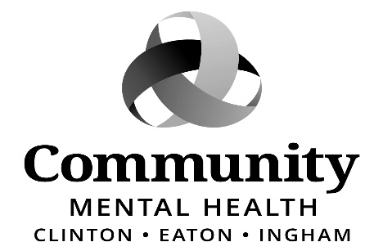

CEO SEARCH COMMITTEE
MEETING
Wednesday, June 10, 2026
4:30 pm
CMHA-CEI, G11-C
812 E. Jolly Road
Lansing, MI 48910

Join Zoom Meeting
https://zoom.us/j/98632487661

Meeting ID: 986 3248 7661

AGENDA
- Call to Order
- Approval of Meeting Minutes – Wednesday, May 21, 2026
- Adoption of Agenda
- Public Comment

BUSINESS ITEMS:
5. Review Interview Questions Jana Baylis, Chief HR Officer
6. CEO Contract Language Follow-up
7. Unfinished Business
8. New Business
9. Public Comment
10. Adjournment
*Denotes Business Item for Action

Please contact Aleshia Echols (517)346-8238. If, however, you are deaf/hard of hearing or deaf/blind, please call Michigan Relay Center, TTY/Voice 844-578-6563 and ask them to forward your message to the above number. These requests must be made no later than 48 hours prior to the meeting.

