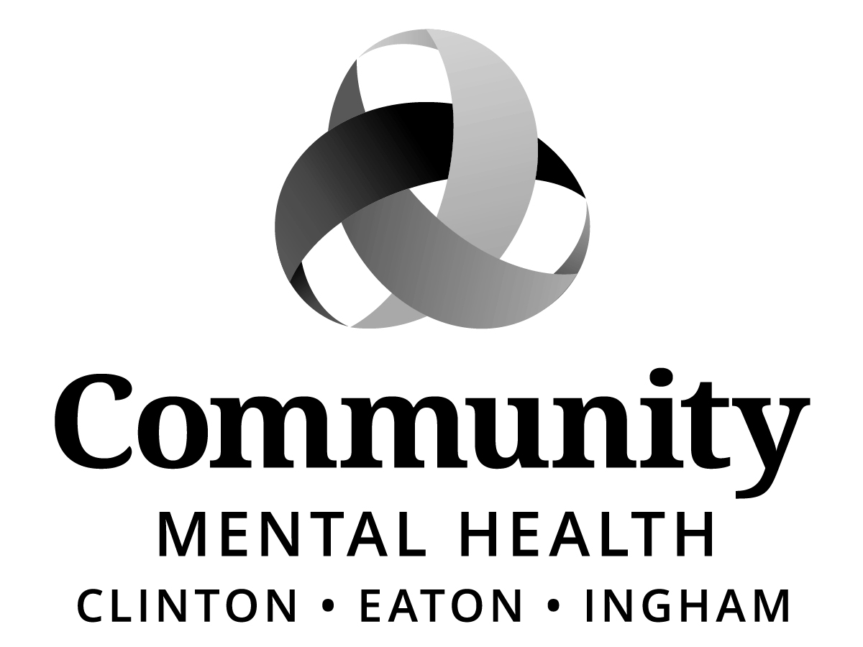

BOARD OF DIRECTORS
HYBRID MEETING
MINUTES
Thursday, January 22, 2026
5:30 pm
CMHA-CEI
812 E. Jolly Road, G11-C
Lansing, MI 48910

Staff Present (Via Zoom)
Shana Badgley, Jana Baylis, KC Brown, Brandon Dotson, Drew Kerjses, Sue McCarthy, Sue Panetta, Jennifer Stanley, Gwenda Summers

Excused:
None.

Staff Present (In-Person)
Aleshia Echols, Sara Lurie, Elise Magen, Kristy Medes

Public Present (In-Person)
Michelle LaLone, CAC Member

Public Present (via Zoom)
Luna Brown, CAC Representative
Faith Halick, CAC Member

Union Representation
Brianna Welch-Vliek, 459

Call to Order:
The meeting was called to order by Board Chair, Jeanne Pearl-Wright at 5:30 pm.

Roll Call:
Jeanne Pearl-Wright, Dale Copedge, Dwight Washington, Tim Hanna, Paula Yensen, Ryan Sebolt, Dianne Holman, Lisa Alicea, Maxine Thome, Jason White, Daniel Arnold

Board Member(s) Attending via Zoom
None.

Excused:
None.

Previous Meeting Minutes
ACTION:
MOVED by Maxine Thome and SUPPORTED by Ryan Sebolt that the Board of Directors of Community Mental Health Authority of Clinton, Eaton and Ingham Counties (CMHA-CEI) approve the December 18, 2025 CMHA-CEI Board of Directors Meeting Minutes with the following addition/corrections:
- Under public present add: Faith Halick, CAC Member
- Correct spelling of Lisa Alicea’s name from Alecia to Alicea

MOTION CARRIED unanimously.

Adoption of Meeting Agenda:
ACTION:
MOVED by Dale Copedge and SUPPORTED by Lisa Alicea that the Board of Directors of Community Mental Health Authority of Clinton, Eaton and Ingham Counties (CMHA-CEI) approve the January 22, 2026 Meeting Agenda.

MOTION CARRIED unanimously.
Public Comment on Agenda Items
None.

Welcome and Announcements
CEO Sara Lurie officially welcomed Daniel Arnold as a member of the CMHA-CEI Board of Directors effective January 1, 2026 through March 31, 2026. At that time, Daniel will need to re-apply for another 2-year term. Additionally, CEO Lurie announced that the Consumer Advisory Council (CAC) has named Luna Brown as the CAC Representative and Faith Halick as the CAC alternate.

CAC Representative Update
CAC Representative, Luna Brown presented the January 8, 2026 Report. Highlights included:
- Molly Simon, Crisis Services Unit, Supervisor presented information about the Crisis Care Center (CCC), the new Crisis Stabilization Unit (CSU), and project timelines. CAC members shared their thoughts and provided feedback.
- Luna Brown was appointed as the next CAC Representative to the Board and Faith Halick was appointed as the back-up CAC Representative to the Board.
- Elected and Appointed Officials CAC Presentation was discussed, with focus on which topics would be most helpful to bring to that audience. Potential topics suggested included orienting attendees to the CAC, stigma and ablism, police involvement in crisis care, insurance coverage issues, and advocacy for continuation of the CCBHC demonstration project.
- CAC New Member Application. The revised application will be reviewed and finalized at the February meeting.

Suggested Future Agenda Topics: None provided at this time.

There were no recommendations to the Board of Directors from CAC.

The next CAC meeting is scheduled for Thursday, February 5, 2026 @ 3:30 pm.

Mid-State Health Network Update
CMHA-CEI Board of Director, Tim Hanna reported that MSHN met a couple of weeks ago. However, there was not a quorum. Additionally, the Court of Claims had not come out with a ruling opinion. Since that time, the Court ruling has been released, and I would like to defer to Sara’s report for further discussion.

CEO Report
CEO, Sara Lurie introduced Elise Magen, QCSRR Director, who in turn introduced Kristy Medes, Customer Service Supervisor who presented on the Customer Service System. Highlights from the presentation included the following:
- Access, Records, Customer Service.
- Access Goals and Objectives.
- Access – FY25: Total Calls, Total Inquiries Completed, Total Intakes Scheduled, and Community Referrals Processed.
- Access – Historical: FY2022 thru FY2025 Total Calls and Calls Answered by a Live Agent.
- Records, Goals and Objectives.
- Records – FY25: Record Destruction project and Total number of Charts: 74,887
- Customer Service Goals and Objectives
- Customer Service Client Interactions (Alternative Dispute Resolution Process, State Fair Hearing, Appeals, Grievances, Consultations) – Historical FY24-25
- Language Services (LEP) Interpretation – Top five languages include: Spanish, Arabic, American Sign Language, Pushto, Swahili (786 encounters)
- What to expect from Customer Services in FY26.

Discussion ensued regarding the new standard practice that has been put place of assignment of a Mental Health Workers (MHW)/Hospital Case Manager at discharge to assist individuals with connecting to services, transportation and other immediate needs. This has been a huge quality of life improvement.

Kristy Medes also shared that all translators/interpreters are required to be certified.

CEO Report continued
CEO Lurie, thanked the QCSRR staff, Elise Magen and Kristy Medes for the Customer Service presentation this evening.

Zero Suicide
- Board member, Paula Yensen inquired about the reality of zero suicide? Director, Shana Badgley shared that this is a big step the agency is taking to standardize how we identify the presence of suicide risk. Staff can take online training for the C-SSRS as well as Counseling on Access to Lethal Means (CALM) in Relias. We will be using their feedback to help determine the best way to move forward with our suicide risk screening process.
PIHP
CEO Lurie reported that we continue to feel positive about the outcome of the court opinion; reporting that she recently learned that MDHHS has until January 29th to file a motion for reconsideration. To date, we have not heard anything about MDHHS next steps.

FY27 State Budget Development
- Revenue estimating conference recently projects $60 million dollars less in State General Fund than currently budgeting in FY26.
- Governor Whitmer presents the Executive Budget Proposal in February.
- We will be looking for information on how the State plans to manage federal Medicaid changes that hit in January 2027.
- Advocacy around increased general fund allocation and adequate rate setting that takes into account declining enrollments.
- Legislation to assure support of CCBHC post demonstration.

Federal
CCBHC continues to experience bipartisan support with introduction of Ensuring Excellence in Mental Health Act (S.3402). Among other provisions, the bill would:
- Establish the CCBHC prospective payment system as a sustainable option for states implementing the model under the state Medicaid option. This allows states to expand the availability of evidence-based services, increase their workforce and integrate services with other providers in their communities.
- Advance care integration by enabling CCBHCs to provide additional services, including primary care.
- Establish CCBHCs as a provider type with prospective payment in Medicare, strengthening their ability to serve older adults.

Recent SAMHSA Reductions Announced and then rescinded the next day
On Jan. 13, the Substance Abuse and Mental Health Services Administration (SAMHSA) sent a letter to numerous agency grant recipients stating that certain grants have been terminated to nonprofit groups, many providing street-level care to people experiencing addiction, homelessness and mental illness. The stated reason for the terminations provided in the letter is that SAMHSA may terminate a federal award “to the extent authorized by law, if an award no longer effectuates the program goals or agency priorities.” Initial estimates suggested approximately 2,800 grants totaling nearly $2 billion had been canceled.

On Jan. 14, the Department of Health and Human Services rescinded its decision to cancel the grants.

Procedures should there be ICE inquiries at our facilities
CEO, Lurie reported that CMHA-CEI will be distributing updated procedure to staff.

COMMITTEE REPORTS
Program & Planning (P&P) Committee
For the month of January, Program & Planning (P&P) Committee Meeting was canceled due to lack of Agenda Items.

Finance Committee
Revenue Lease Renewal Contract: Affiliated Health Services Inc. Pharmacy
ACTION:
MOVED by Tim Hanna and SUPPORTED by Dale Copedge that the Board of Directors of Community Mental Health Authority of Clinton, Eaton and Ingham Counties (CMHA-CEI) authorize CMHA-CEI to lease the property at 812 E. Jolly Road Suite 208, Lansing, Michigan 48910 to Affiliated Health Services Inc. DBA Henry Ford Affiliated Health Services Inc. Pharmacy, for the period of three years beginning October 1, 2025, and ending September 30, 2028, in which they will pay as follows to CMHA-CEI:

Total annual rent of $43,135.95 paid in consecutive monthly installments of $3,594.66.
Board member, Paula Yensen requested to receive the budget in advance from Rehmann consultant. CEO, Lurie concurred. Sue Panetta, Chief Financial Officer advised that the audited financial statement is due the end of March.

MOTION CARRIED unanimously.

Special Executive Committee
Operational Values Policy, 1.1.24
ACTION:
MOVED by Jeanne Pearl-Wright and SUPPORTED by Maxine Thome that the Board of Directors of Community Mental Health Authority of Clinton, Eaton and Ingham Counties (CMHA-CEI) accept the approval of the Operational Values Policy, 1.1.24 incorporating the recommended changes.

MOTION CARRIED unanimously.

Community Access Committee
Dianne Holman, committee Chair shared that the next CAC meeting is scheduled for January 26, 2026 at 5:30 pm, G11-C conference room.

Unfinished Business
Raul Gonzales Resolution
Board member, Dale Copedge inquired as to whether CMHA-CEI Administration has been able to connect with Raul Gonzales’ family to deliver the resolution and lantern? CEO Lurie advised that we have not yet been able to connect.

ACTION: CEO Lurie will reach out via US certified mail.

New Business
Appointment of new Finance Committee Member
ACTION:
MOVED by Tim Hanna and SUPPORTED by Dale Copedge that the Board of Directors of Community Mental Health Authority of Clinton, Eaton and Ingham Counties (CMHA-CEI) accept the nomination of Lisa Alicea on the Finance Committee effective January 22, 2026 through April 30, 2026.

MOTION CARRIED unanimously.

Unfinished Business
Revised 2026 Calendar of Board and Committee Meeting Schedule
Due to additions to the calendar and some meeting cancellations, a hard copy of the revised 2026 Calendar of Board and Committee Meeting Schedule was distributed.

Public Comment
Dale Copedge, Lisa Alicea, Dianne Holman, Paula Yensen, Dwight Washington, Maxine Thome all agreed that this year’s MLK Holiday Commission Luncheon was phenomenal. All thoroughly enjoyed the program, especially the special remarks by Diane Nash and keynote speaker, Michigan Supreme Court Justice, The Honorable Justice Kyra H. Bolden.

Board member Tim Hanna shared that the Sparrow Board and Board of Region is voting on the behavioral health facility on February 19th., and are looking at a two phase plan with completion in 2028.

Adjournment
The meeting adjourned at 6:48 p.m. The next regular meeting is scheduled for Thursday, February 19, 2026, at 5:30 p.m., and will take place at CMHA-CEI, 812 E. Jolly Road, Lansing, MI 48910.

Minutes Submitted by:
Aleshia Echols, Executive Administrative Assistant

