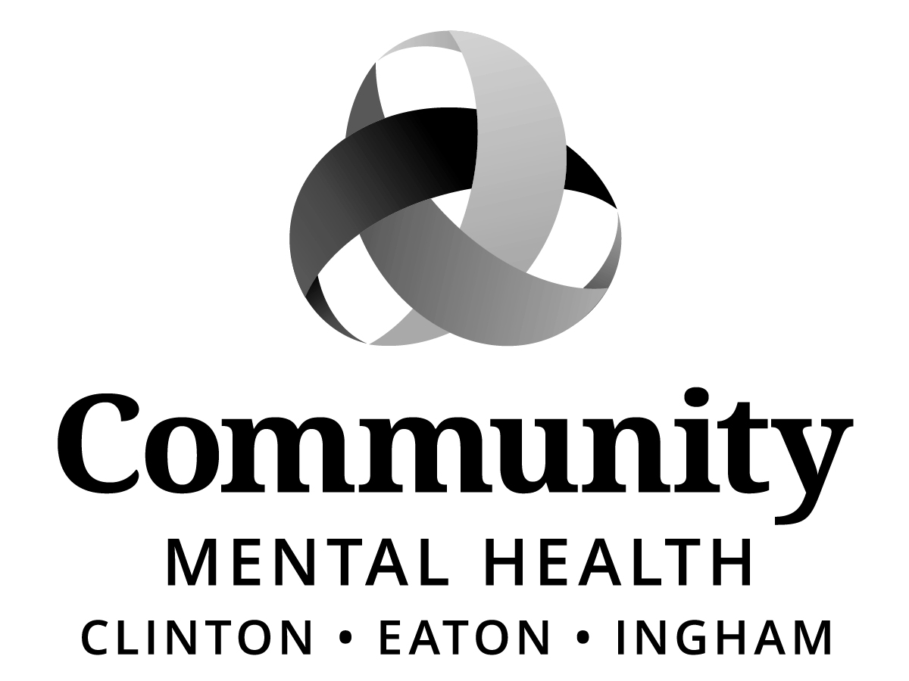

BOARD OF DIRECTORS
HYBRID MEETING
MINUTES
Thursday, March 19, 2026
5:30 pm
CMHA-CEI
812 E. Jolly Road, G11-C
Lansing, MI 48910

Staff Present (Via Zoom)
Jana Baylis, Shana Badgley, KC Brown, Brandon Dotson, Faith Halick, Drew Kersjses, Elise Magen, Sue Panetta, John Peiffer, Gwenda Summers

Excused:
Jennifer Stanley

Staff Present (In-Person)
Shana Badgley, Aleshia Echols, Sara Lurie, Morgan McKittrick, Leah Tarrent, Gwen Williams

Public Present (In-Person)
Luna Brown (she/her), CAC Representative
Michelle LaLone, CAC Member
Faith Halick, CAC Member

Public Present (via Zoom)
None.

Union Representation
None.

Call to Order:
The meeting was called to order by Board Chair, Jeanne Pearl-Wright at 5:32 pm.

Roll Call:
Jeanne Pearl-Wright, Dale Copedge, Dwight Washingon, Paula Yensen, Tim Hanna, Dianne Holman, Lisa Alicea, Maxine Thome, Jason White, Daniel Arnold

Board Member(s) Attending via Zoom
None.

Excused:
Ryan Sebolt

Previous Meeting Minutes
ACTION:
MOVED by Paula Yensen and SUPPORTED by Dwight Washington that the Board of Directors of Community Mental Health Authority of Clinton, Eaton and Ingham Counties (CMHA-CEI) approve the February 19, 2026, CMHA-CEI Board of Directors Meeting Minutes as written.

MOTION CARRIED unanimously.

Adoption of Amended Meeting Agenda:
ACTION:
MOVED by Dale Copedge and SUPPORTED by Dwight Washington that the Board of Directors of Community Mental Health Authority of Clinton, Eaton and Ingham Counties (CMHA-CEI) approve the March 19, 2026, Amended Meeting Agenda with the following changes:
- Item IX. Assessment & Referral Team (ART) Presentation moved to item VIII.
- Item VIII. CEO Report moved to item IX.
- Add 2026 CMHAM Contribution under New Business Item #3

MOTION CARRIED unanimously.
Public Comment on Agenda Items
None.

CAC Representative Update
CAC Representative, Luna Brown presented the March 5, 2026, Report. Highlights included:
- Approval of By-Laws
- Crisis Care Center (CCC) Tour, March 25, 2026 from 1:30 – 3:30pm.
- Elected and Appointed Officials Presentation by CAC on Monday, April 27. Members of CAC will participate in a panel discussion as well as field questions from attendees.
- Review of Application
- Project Starfish

There were no recommendations to the Board of Directors from CAC.

The next CAC meeting is scheduled for Thursday, April 2, 2026 @ 3:30 pm., and will be held via Zoom.

Mid-State Health Network Update
CMHA-CEI Board of Director member, Tim Hanna reported that MSHN met on March 3rd, reporting that there was a lot of discussion regarding the favorable court ruling. However, there still is no clear direction for the PIHP. Additionally, there is a hearing to dismiss the case scheduled for April 14th, which the State supports. MDHHS has scheduled listening sessions for the CMHP Directors on March 2 and for the PAIHPs on March 5th.

Lastly, board member Hanna reported that the November 30th financial trend revenues are greater than the expenses. However, money is owed to the State for the previous year.

CEO Lurie commented on the tone of the listening sessions and reported that Judge Yates is scheduled to retire May 1, 2026.

CEO Report
CEO Sara Lurie introduced Shana Badgley, AMHS Director, who in turn introduced
Gwen Williams, AMHS Supervisor (employed over 30 years with CMHA-CEI)
Leah Tarrent, Coordinator (employed over 15 years of service with CMHA-CEI)

Highlights from the presentation included:
- History of AMHS Assessment & Referral Process
- (ART) started December 2005 with 2 MHT Assessment staff, in-house psychiatry, schedule for 3 – 4 per day, with LOC.
- Present Day ART has expanded to 7 MHT Assessment staff, no wrong door, 1 MHW, Walk-in hours now provided (CCBHC), began February 2021, work closely with Court and Community Liaison Team, option for Hospital inpatient and Residential SUD inpatient assessments on case-by-case basis
- Assessments by the Numbers – Switched from scheduled assessments to walk-in assessment in February, 2021. In June, 2022 moved to no denials for services
- ART Assessments by Month
- ART Assessments Yearly Totals
- Data at a glance
- Summer/Fall 2026, ART will be moving to the Crisis Care Center

CEO Report continued
CEO Lurie thanked the ART team for their presentation this evening. Other items discussed included:

Board Chair Recognition
CEO Lurie reported that this evening would be Jeanne Pearl-Wright’s last meeting for her term reporting that we will present Jeanne with a plaque at the April 16th meeting.

Clinical Philosophy Cards
CEO Lurie distributed copies of the clinical philosophy cards to board members and shared that several of the clinical leaders worked for many months to develop values that we all embrace.

The card reads as follows:
Community Mental Health Authority of Clinton, Eaton, and Ingham Counties (CMHA-CEI) is committed to providing excellent behavioral health care.

We aspire to provide care that is individualized, trauma informed, holistic, person-centered, and strength-based.

We strive to provide services driven by the value of diversity, equity, inclusion, and justice to empower people.

We consistently engage in professional growth to expand our knowledge, improve service delivery, and increase access to resources.

We are dedicated to creating solutions with those we support through collaboration.

We believe unconditional dignity and respect are vital to the success of those we serve in our community.

ACTION: Copies continue to be distributed to new and existing staff, and large posters have been ordered which will be displayed throughout the building.

Board Member CCC Tours
CEO Lurie reported that CCC tours have been scheduled for CMHA-CEI Board of Directors and CAC members for next Wednesday, March 25th, and on Thursday, March 26 for Elected and Appointed Officials.

CEO commented that she is looking forward to hearing from CAC members based on the outcome of the facility as CAC members dedicated a lot of time and input regarding the facility artwork and furniture selections.

Rebid
MiPlan Transitional Board met on last Friday to discuss whether to disband or stay the course to see what happens next (dismissal, issuance of a new RFP with a short timeline). The decision was to stay the course.

Medicaid Recertifications and State Rates
CEO Lurie shared that the biggest concern that we have at this time are the individuals falling off Medicaid (mild to moderate) as many of those who receive services will qualify for an exemption. If the State rate does not increase, we will not have the funds to provide services.

Discussion ensued regarding the requirement communication that went out from the State to Medicaid beneficiaries and the fact that it created a lot of stress.

ACTION: Board member Daniel Arnold inquired about the possibility of scheduling a date consumers could come in to either Charter House or JIMHO to receive assistance with paperwork.

ACTION: Directors Group will be reviewing reports/protocols looking at those who are falling off Medicaid, reporting that missed appointments and administrative cost to State continues to be an issue.

Annual Community Breakfast
The Annual Community Event is scheduled as follows:

Date: Monday, March 23, 2026
Time: 9:30 am – 12:00 noon
Location: Lansing Center, 333 Michigan Avenue, Lansing, MI 48933

Keynote speaker: Kevin Fischer, NAMI Michigan Executive Director

ACTION: If interested in attending, please let Aleshia know and she will be happy to submit your registration or register @ https://bit.ly/2026CMHACEIAnnualEvent.

CEO Lurie reported that she plans to have a moment of silence for those CMHA-CEI board members and other community pillars we lost in 2025 which include:
- Al Platt
- Raul Gonzales
- Jason Blanks, Capital Area Health Alliance
- Larry Leatherwood, Uplift of Youth

COMMITTEE REPORTS
Program & Planning (P&P) Committee
New Expense Contract: Guardianship and Alternatives, Inc.
ACTION:
MOVED by Lisa Alicea and SUPPORTED by Paula Yensen that the Board of Directors of Community Mental Health Authority of Clinton, Eaton and Ingham Counties (CMHA-CEI) authorize CMHA-CEI to enter into a new contract with Guardianship and Alternatives, Inc. to purchase services indicated at the rates below for the period of March 1, 2026, through September 30, 2026.

Agency Name | Address | Service
Guardianship and Alternatives, Inc. | P.O. Box 240  Dowagiac, MI 49047 | Guardianship Services

Services as approved by Program Liaison | Amount per month per consumer
Guardianship Services without Payee Services | $78.00
Guardianship Services with Payee Services | $83.00

MOTION CARRIED unanimously.

New Expense Contract: Sheraton Detroit Novi Hotel
ACTION:
MOVED by Lisa Alicea and SUPPORTED by Tim Hanna that the Board of Directors of Community Mental Health Authority of Clinton, Eaton and Ingham Counties (CMHA-CEI) authorize CMHA-CEI to enter into a contract with Sheraton Detroit Novi Hotel and pay no more than $97,400 for those services for the period of May 4, 2027, through May 6, 2027.

MOTION CARRIED unanimously.

2026 CMHA-CEI Quality Improvement Program Plan
2025 Quality Improvement Program Plan Effectiveness Report
2026 Mid-State Health Network Quality Assessment and Performance Improvement Program and the 2025 Annual Effectiveness and Evaluation Report
ACTION:
MOVED by Lisa Alicea and SUPPORTED by Tim Hanna that the Board of Directors of Community Mental Health Authority of Clinton, Eaton and Ingham Counties (CMHA-CEI) authorize CMHA-CEI to approve the adoption of the 2026 CMHA-CEI Quality Improvement Program Plan and the 2025 Quality Improvement Program Plan Effectiveness Report, and of the 2026 Mid-State Health Network Quality Assessment and Performance Improvement Program and the 2025 Annual Effectiveness and Evaluation Report.

MOTION CARRIED unanimously.

Finance Committee
Expense Contract Amendment: HFHS – Acadia Joint Venture, LLC DBA Henry Ford Health Behavioral Health Hospital
ACTION:
MOVED by Tim Hanna and SUPPORTED by Lisa Alicea that the Board of Directors of Community Mental Health Authority of Clinton, Eaton and Ingham Counties (CMHA-CEI) authorize CMHA-CEI to approve the amendment to purchase Outpatient ECT services to add to the existing hospital services contract with HFHS - Acadia Joint Venture, LLC DBA Henry Ford Health Behavioral Health Hospital in accordance with the rate schedule shown below for the period of March 19, 2026, through September 30, 2026.

Hospital
HFHS - Acadia Joint Venture, LLC DBA Henry Ford Health Behavioral Health Hospital
7100 Berryhill Street, West Bloomfield, Michigan 48322

Services | Billing Code | Unit | Rate
Outpatient ECT (Inclusive of Physician Fees) | 0901 | Per Encounter | $1,150
Inpatient ECT (Inclusive of Physician Fees) in addition to inpatient per diem | 0901 | Per Encounter | $1,150

MOTION CARRIED unanimously.

New Expense Contract: Insight Corporation
ACTION:
MOVED by Tim Hanna and SUPPORTED by Maxine Thome that the Board of Directors of Community Mental Health Authority of Clinton, Eaton and Ingham Counties (CMHA-CEI) authorize CMHA-CEI to contract with Insight Corporation to develop and implement Microsoft Purview Data Loss Prevention policies across our Microsoft Tenant and then facilitate in migrating agency file shares to SharePoint Online sites for a cost of $59,745.00.

MOTION CARRIED unanimously.

Expense Contract Renewal: Mirazon Group
ACTION:
MOVED by Tim Hanna and SUPPORTED by Maxine Thome that the Board of Directors of Community Mental Health Authority of Clinton, Eaton and Ingham Counties (CMHA-CEI) authorize CMHA-CEI to renew our DataCore license and maintenance through Mirazon Group from April 1, 2026, to March 31, 2027, and pay $69,216.94 for that license and maintenance.

MOTION CARRIED unanimously.

812 E. Jolly Road – Parking Lot Replace Asphalt Paving, West Side
ACTION:
MOVED by Tim Hanna and SUPPORTED by Maxine Thome that the Board of Directors of Community Mental Health Authority of Clinton, Eaton and Ingham Counties (CMHA-CEI) authorize CMHA-CEI to enter into an expense contract with Tomco Asphalt - 3694 West Columbia Road Mason, Michigan 48854 for this asphalt project in the amount of $163,308 to replace the West area of the building parking lot with new asphalt at 812 East Jolly Road, Lansing, Michigan. This asphalt work is the last of a three-phase three-year project being completed to replace and upgrade existing asphalt paving that is now 25 years old. Repaving will include improving the subbase to include compacted gravel per industry standards and best practices.

MOTION CARRIED unanimously.

Executive Committee
Slate of Officers
ACTION:
MOVED by Jeanne Pearl-Wright and SUPPORTED by Dianne Holman that the Board of Directors of Community Mental Health Authority of Clinton, Eaton and Ingham Counties (CMHA-CEI) accept the Slate of officers, Dale Copedge, Board Chair; Dwight Washington, Board Vice-Chair; and Ryan Sebolt, Board Secretary effective April 1, 2026 through March 31, 2027.

MOTION CARRIED unanimously.

Recipient Rights Committee
Recipient Rights Quarterly Report: July 1, 2025 – September 30, 2025
ACTION:
MOVED by Dale Copedge and SUPPORTED by Dwight Washington that the Board of Directors of Community Mental Health Authority of Clinton, Eaton and Ingham Counties (CMHA-CEI) authorize CMHA-CEI to accept the Recipient Rights Quarterly Report for the period of July 1, 2025 – September 30, 2025.

MOTION CARRIED unanimously.

Recipient Rights Quarterly Report: October 1, 2025 – December 31, 2025
ACTION:
MOVED by Dale Copedge and SUPPORTED by Dwight Washington that the Board of Directors of Community Mental Health Authority of Clinton, Eaton and Ingham Counties (CMHA-CEI) authorize CMHA-CEI to accept the Recipient Rights Quarterly Report for the period of October 1, 2025 – December 31, 2025.

MOTION CARRIED unanimously.

Human Resources Committee
First Quarter Diversity Initiative and EEO Report
ACTION:
MOVED by Maxine Thome and SUPPORTED by Dwight Washington that the Board of Directors of Community Mental Health Authority of Clinton, Eaton and Ingham Counties (CMHA-CEI) authorize CMHA-CEI to accept the First Quarter Diversity Initiative and EEO Report from October 1, 2025, through December 31, 2025.

MOTION CARRIED unanimously.

First Quarter Labor Relations Grievance Report
ACTION:
MOVED by Maxine Thome and SUPPORTED by Paula Yensen that the Board of Directors of Community Mental Health Authority of Clinton, Eaton and Ingham Counties (CMHA-CEI) authorize CMHA-CEI to accept the First Quarter Labor Relations Grievance Report from October 1, 2025, through December 31, 2025.

MOTION CARRIED unanimously.

Letter to Board from Retiree
ACTION:
MOVED by Maxine Thome and SUPPORTED by Paula Yensen that the Board of Directors of Community Mental Health Authority of Clinton, Eaton and Ingham Counties (CMHA-CEI) authorize CMHA-CEI to accept the report from legal on behalf of the Human Resources Committee.

MOTION CARRIED unanimously.

Community Access Committee
- Dianne Holman, Committee Chair announced that the March 30th meeting has been cancelled. The next regular meeting is scheduled for Monday, June 1, 2026 @ 5:30 p.m., G11-C conference room.

Unfinished Business
None.

New Business
New Expense Contract: Culinary Services Group
ACTION:
MOVED by Maxine Thome and SUPPORTED by Dianne Holman that the Board of Directors of Community Mental Health Authority of Clinton, Eaton and Ingham Counties (CMHA-CEI) authorize CMHA-CEI to enter into a new contract with Culinary Services Group to purchase Central Kitchen Food Services for the Crisis Care Center and pay up to $783,304 annually for the period of April 1, 2026 through September 30, 2028.

MOTION CARRIED unanimously.

Chief Executive Officer Search – Information Only
ACTION:
MOVED by Lisa Alicea and SUPPORTED by Jason White that the Board of Directors of Community Mental Health Authority of Clinton, Eaton and Ingham Counties (CMHA-CEI) accept the Search Committee recommendation of the Executive Committee of Dwight Washington, Tim Hanna, Dale Copedge, Jeanne Pearl-Wright, Maxine Thome.

MOTION CARRIED unanimously.

Discussion
Chief Human Resources Officer, Jana Baylis presented the CEO Search timeline. Board member, Tim Hanna inquired as to whether the search committee meetings fall under the Open Meetings Act or whether the meetings could be attended via Zoom since they are more data collection in nature and the team will be serving in an advisory capacity; with no voting taking place?

ACTION: Chief Human Resource Officer, Jana Baylis will follow-up with legal and advise.

Board member, Paula Yensen inquired as to why we are not conducting a National search and using a headhunter/consultant? Chief Human Resources Officer, Jana Baylis advised that we may. However, at this time we would like to review the pool of candidates as well as the number of applicants once the position is posted and advised that National searches tend to be quite expensive.

ACTION: Chief Human Resources Officer, Jana Baylis advised that HR will coordinate the search committee meeting schedule. Additionally shared that the posting is scheduled to go up in April.

2026 CMHAM Contribution
ACTION:
MOVED by Jeanne Pearl-Wright and SUPPORTED by Dwight Washington that the Board of Directors of Community Mental Health Authority of Clinton, Eaton and Ingham Counties (CMHA-CEI) authorize CMHA-CEI to contribute $50,000 to CMHAM for continued advocacy in 2026.

MOTION CARRIED unanimously.

Public Comment
Board member, Maxine Thome announced the following AIDS Walk, which CMHA-CEI Diversity Advisory Council members will also be participating.

Lansing Area AIDS WALK at Edgewood United Church, 469 N. Hagadorn Road, East Lansing, MI 48823. Below please find the link to register: https://crm.bloomerang.co/HostedDonation?ApiKey=pub_a0971d3e-bc64-11ee-96cb-0a3287177f03&WidgetId=1180672

Luna Brown expressed that she was happy to see the Children Integrated Center article in the Annual Report and expressed the importance of moving forward to provide this service to the Adult population while breaking down silos and gaps in coverage for therapy due to high acuity needs, as well as the lack of access to therapist in the community and in the private sector. Luna shared that she experienced this first-hand during the time she was receiving care through CSDD and expressing that it was less than satisfactory.

Board member, Daniel Arnold acknowledged the beautiful set up including the Annual Report and gift bags from the Annual Event.

Adjournment
The meeting adjourned at 7:23 p.m. The next regular meeting is scheduled for Thursday, April 16, 2026, at 5:30 p.m., and will take place at CMHA-CEI, 812 E. Jolly Road, Lansing, MI 48910.

Minutes Submitted by:
Aleshia Echols, Executive Administrative Assistant

