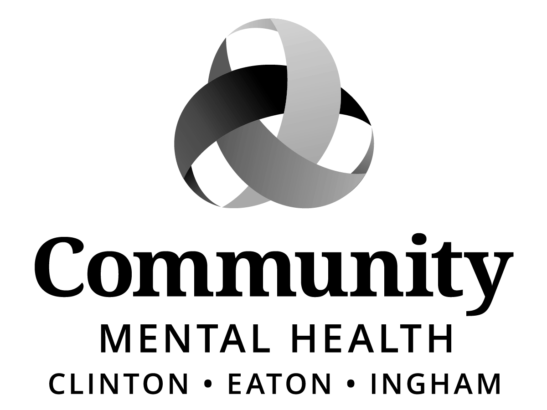
Board of Directors:
Dale Copedge, Chair
Dwight Washington, Vice Chair
Ryan Sebolt, Secretary
Timothy Hanna
Dianne Holman
Lisa Alicea
Daniel Arnold
Jeanne Pearl-Wright
Maxine Thome
Jason White
Paula Yensen
Allen Way

Paul Palmer

BOARD OF DIRECTORS
“HYBRID” MEETING
Thursday, September 17, 2026
5:30 p.m.
Community Mental Health Authority - CEI
812 E. Jolly Road, G11-C
Lansing, MI 48910

Join Zoom Meeting
https://zoom.us/j/96496659845

Meeting ID: 964 9665 9845
AGENDA
I. CALL TO ORDER
II. ROLL CALL
III. PREVIOUS MEETING MINUTES - August 20, 2026
IV. ADOPTION OF AGENDA
V. PUBLIC COMMENT ON AGENDA ITEMS
VI. CAC REPRESENTATIVE UPDATE Luna Brown, CAC Representative
VII. MID-STATE HEALTH NETWORK UPDATE Dwight Washington and Jason White MSHN Boards Appointees
VIII. CEO REPORT Sara Lurie, Chief Executive Officer
IX. MEDICAL DIRECTOR PRESENTATION Dr. Jennifer Stanley
X. COMMITTEE REPORTS
BUSINESS ITEMS:
Program & Planning Committee
Meeting Cancelled.

Finance Committee
*1. Expense Contract Renewal: Michigan Department of Labor and Economic Opportunity – Michigan Rehabilitation Services – CESP & SEP
*2. Fiscal Year 2027 Contract Renewals for Clinical Services
*3. Fiscal Year 2027 Contract Renewals for Facility Respite Services
*4. Fiscal Year 2027 Contract Renewals for Community-Based Services
*5. Fiscal Year 2027 Contract Renewals for Non-Clinical Service
*6. Fiscal Year 2027 Contract Renewals for Specialized Residential Services
*7. Fiscal Year 2027 Contract Renewals for Psychiatric Inpatient, Partial Hospitalization, and Crisis Residential Services
*8. Fiscal Year 2027 Revenue Contract Renewals

HR Committee
Meeting Cancelled.

Recipient Rights
*1. Recipient Rights Quarterly Report: April 1, 2026 – June 30, 2026
*2. Recipient Rights FY27 Budget

Community Access Committee
Next Meeting: Monday, September 28, 2026 @ 5:30 pm, G11-C

X. UNFINISHED BUSINESS

XI. NEW BUSINESS
*1. New Expense Contract: HMCo Environmental Modification, Children’s Supports
Waiver (CSW)
*2. New Single Case Agreement: Children’s Therapy Corner
*3. Fiscal Year 2027 Contract Renewals for Psychiatric inpatient, Partial Hospitalization,
And Crisis Residential Services

XII. PUBLIC COMMENT (3 minutes per speaker)

XIII. ADJOURNMENT
*Action Items
If you need accommodations in order to fully participate in this meeting, please email echols@ceicmh.org. If, however, you are deaf/hard of hearing or deaf/blind, please call Michigan Relay Center, TTY/Voice by dialing 711 or 844-578-6563 and ask them to forward your message to 517-507-6771. Requests must be made no later than 48 hours prior to the meeting. This meeting is open to all members of the public under Michigan’s Open Meetings Act.

