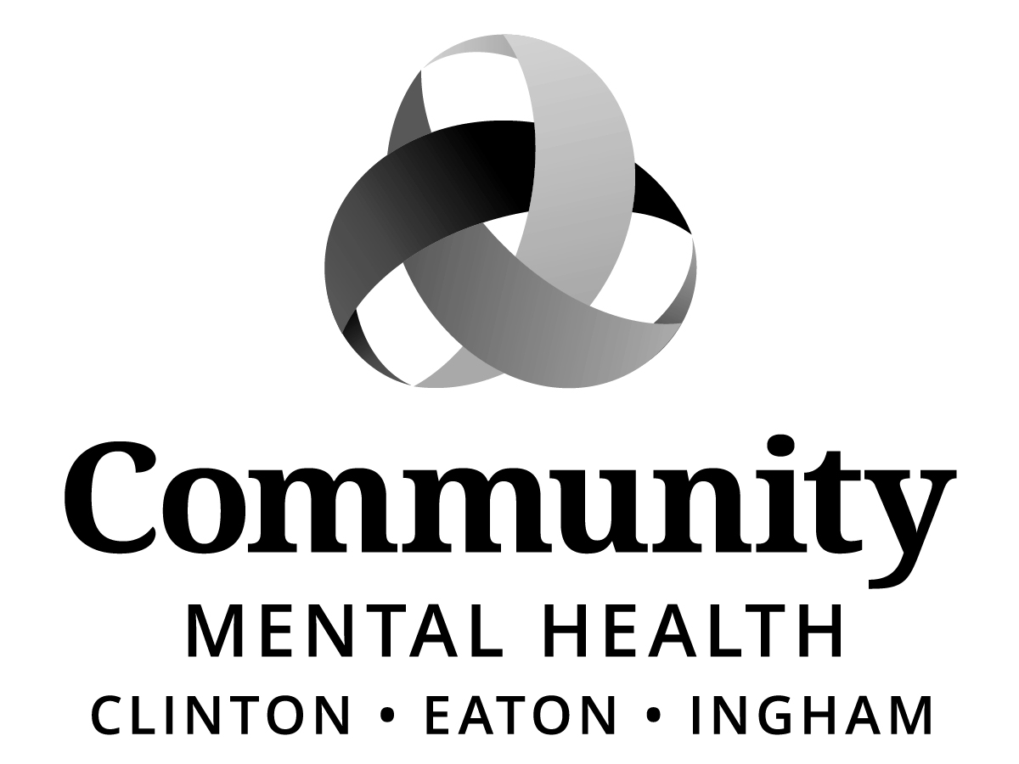
Board of Directors:
Dale Copedge, Chair
Dwight Washington, Vice Chair
Ryan Sebolt, Secretary
Timothy Hanna
Dianne Holman
Lisa Alicea
Daniel Arnold
Jeanne Pearl-Wright
Maxine Thome
Jason White
Paula Yensen
Allen Way

Paul Palmer
BOARD OF DIRECTORS
“HYBRID” MEETING
Thursday, June 18, 2026
10:00 am – 5:00 pm
Barry Eaton District Health Department
1033 Health Care Drive, lower level conference room
Charlotte, MI 48813

Join Zoom Meeting
https://zoom.us/j/97621575249
Meeting ID: 97621575249
Time | Agenda | Zoom Link Information
9:00 – 9:30 am | Board of Directors arrive, breakfast served. | None
9:30 – 10:00 am | HR Interview Orientation | None
10:00 - 10:30 am | PUBLIC COMMENT | http:zoom.us/j/97621575249
10:30 am | MEETING CALLED TO ORDER
10:30 – 11:45am | Candidate #1 - Kareem Baig | http:zoom.us/j/97621575249
11:45 – 12:30 pm | Lunch | None
12:30 – 1:45 pm | Candidate #2 - Shana Badgley | http:zoom.us/j/97621575249
1:45 – 2:05 pm | Break | None
2:05 – 3:20 pm | Candidate #3 - Lisa Walker | http:zoom.us/j/97621575249
3:20 – 3:40 pm | Light Refreshments | None
3:40 – 4:55 pm | Candidate #4 – Gwenda Summers | http:zoom.us/j/97621575249
4:55 pm | PUBLIC COMMENT | http:zoom.us/j/97621575249
 | ADJOURNMENT

