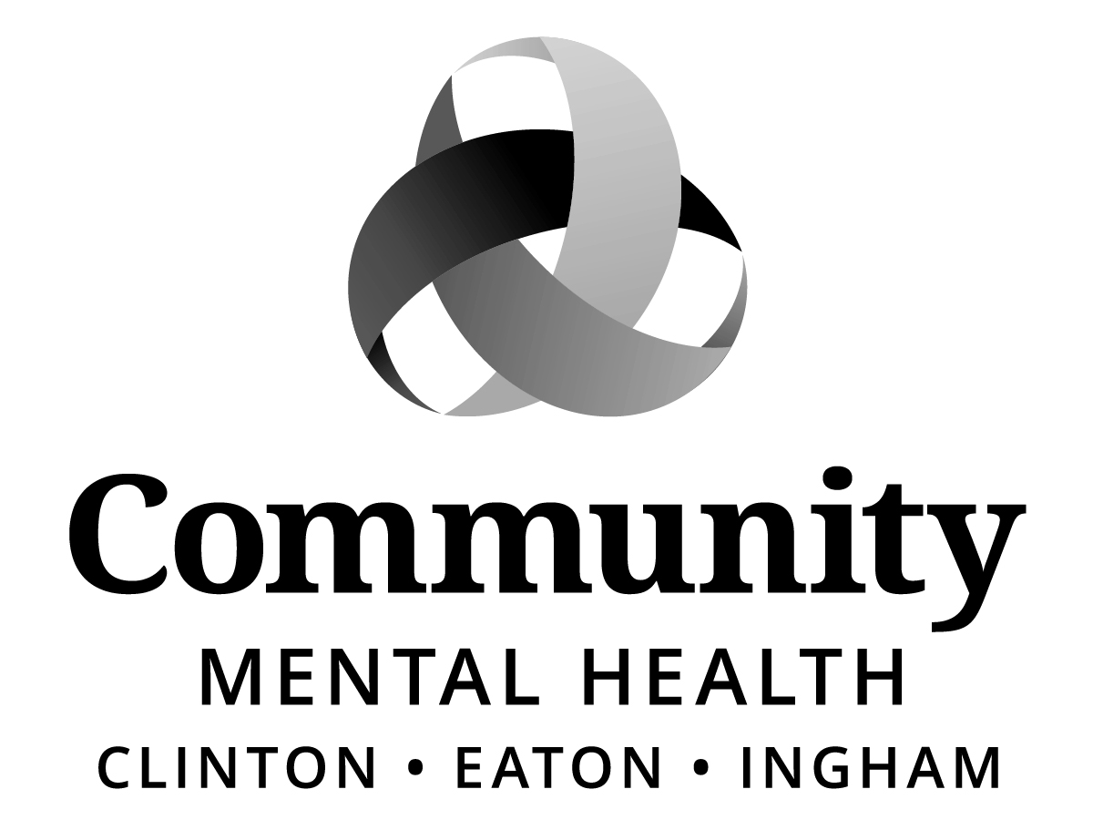
Board of Directors:
Jeanne Pearl-Wright, Chair
Dale Copedge, Vice Chair
Dwight Washington, Secretary
VACANT
Timothy Hanna
Dianne Holman
Lisa Alicea
Daniel Arnold
Ryan Sebolt
Maxine Thome
Jason White
Paula Yensen

Paul Palmer

BOARD OF DIRECTORS
“HYBRID” MEETING
Thursday, March 19, 2026
5:30 p.m.
Community Mental Health Authority - CEI
812 E. Jolly Road, G11-C
Lansing, MI 48910

Join Zoom Meeting
https://zoom.us/j/96496659845

Meeting ID: 964 9665 9845

AGENDA
I. CALL TO ORDER
II. ROLL CALL
III. PREVIOUS MEETING MINUTES - February 19, 2026
IV. ADOPTION OF AGENDA
V. PUBLIC COMMENT ON AGENDA ITEMS
VI. CAC REPRESENTATIVE UPDATE Luna Brown, CAC Representative
VII. MID-STATE HEALTH NETWORK UPDATE Timothy Hanna, MSHN Board Appointee
VIII. CEO REPORT Sara Lurie, Chief Executive Officer
IX. ASSESSMENT & REFERRAL TEAM (ART) Shana Badgley, AMHS Director
PRESENTATION Leah Tarrant, Coordinator
Gwen Williams, AMHS Supervisor
X. COMMITTEE REPORT
BUSINESS ITEMS:
Program & Planning Committee
*1. New Expense Contract: Guardianship and Alternatives, Inc.
*2. New Expense Contract: Sheraton Detroit Novi Hotel
*3. 2026 CMHA-CEI Quality Improvement Program Plan
2025 Quality Improvement Program Plan Effectiveness Report
2026 Mid-State Health Network Quality Assessment and Performance Improvement
Program and the 2025 Annual Effectiveness and Evaluation Report

Finance Committee
*1. Expense Contract Amendment: HFHS – Acadia Joint Venture, LLC DBA
Henry Ford Health Behavioral Health Hospital
*2. New Expense Contract: Insight Corporation
*3. Expense Contract Renewal: Mirazon Group
*4. 812 E. Jolly Road – Parking Lot Replace Asphalt Paving, West Side

Executive Committee
*1. Slate of Officers effective April 1, 2026 – March 31, 2027

Recipient Rights Committee
*1. Recipient Rights Quarterly Report: July 1, 2025 – September 30, 2025
*2. Recipient Rights Quarterly Report: October 1, 2025 – December 31, 2025

Human Resources Committee
*1. First Quarter Diversity Initiative and EEO Report
*2. First Quarter Labor Relations Grievance Report

Community Access Committee
- Next Meeting – Monday, March 30, 2026 @ 5:30 pm.

XI. UNFINISHED BUSINESS

XII. NEW BUSINESS
*1. CEO Search

XIII. PUBLIC COMMENT (3 minutes per speaker)

XIV. ADJOURNMENT
*Action Items
If you need accommodations in order to fully participate in this meeting, please email echols@ceicmh.org. If, however, you are deaf/hard of hearing or deaf/blind, please call Michigan Relay Center, TTY/Voice by dialing 711 or 844-578-6563 and ask them to forward your message to 517-507-6771. Requests must be made no later than 48 hours prior to the meeting. This meeting is open to all members of the public under Michigan’s Open Meetings Act.

