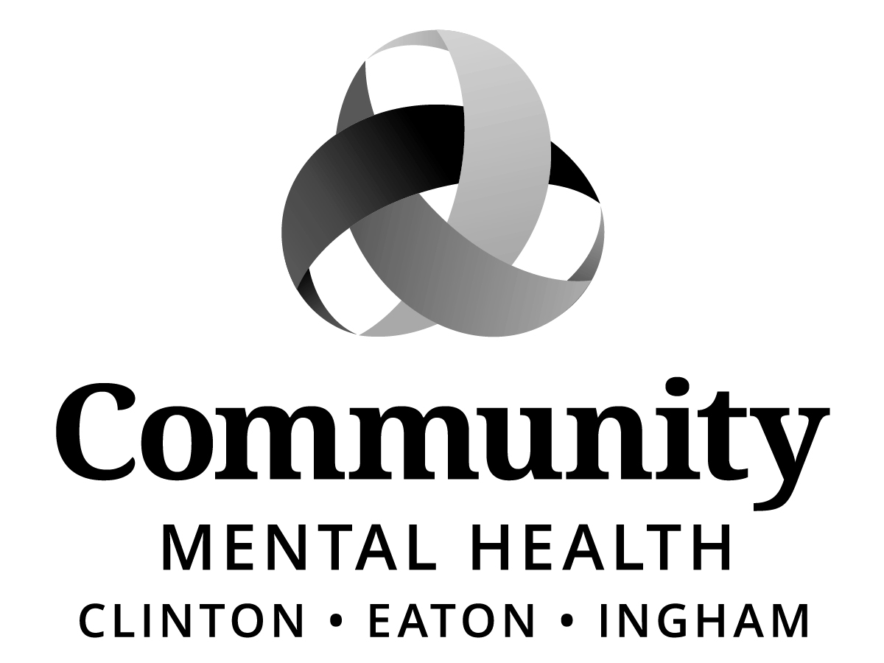
Board of Directors:
Dale Copedge, Chair
Dwight Washington, Vice Chair
Ryan Sebolt, Secretary
Timothy Hanna
Dianne Holman
Lisa Alicea
Daniel Arnold
Jeanne Pearl-Wright
Maxine Thome
Jason White
Paula Yensen
Allen Way

Paul Palmer

SPECIAL
BOARD OF DIRECTORS
“HYBRID” MEETING
Wednesday, July 8, 2026
4:00 p.m.

Community Mental Health Authority, CEI
812 E. Jolly Road, G11-C
Lansing, MI 48910

Join Zoom Meeting
https://zoom.us/j/95084348563

Meeting ID: 950 8434 8563

AGENDA
I. CALL TO ORDER
II. ROLL CALL
III. PREVIOUS MEETING MINUTES - June 18, 2026 Special Board Meeting
IV. ADOPTION OF AGENDA
V. PUBLIC COMMENT ON AGENDA ITEMS
*VI. CEO SEARCH COMMITTEE RECOMMENDATION Dale Copedge, Board Chair
VII. UNFINISHED BUSINESS
VIII. NEW BUSINESS
IX. PUBLIC COMMENT (3 minutes per speaker)
X. ADJOURNMENT

*Action Items
If you need accommodations in order to fully participate in this meeting, please email echols@ceicmh.org. If, however, you are deaf/hard of hearing or deaf/blind, please call Michigan Relay Center, TTY/Voice by dialing 711 or 844-578-6563 and ask them to forward your message to 517-507-6771. Requests must be made no later than 48 hours prior to the meeting. This meeting is open to all members of the public under Michigan’s Open Meetings Act.

